Title： Socket Programming
No.1

Name: Khan Md Shahedul Islam
Stu No.:2018380130
Class No.:10101801
Time: 2020/11/13

School of computer science, NWPU

Content

1 Purpose of the experiment 1
2 Steps for the experiment 1
3 Problems happened to the experiment 1
4 Results and analysis 3

- Aim: Implement the mutual communication between two hosts based on TCP or UDP.
- Principle: Communication procedure of TCP and UDP
- Requirement:
Run the Client and the Server simultaneously on the same computer.

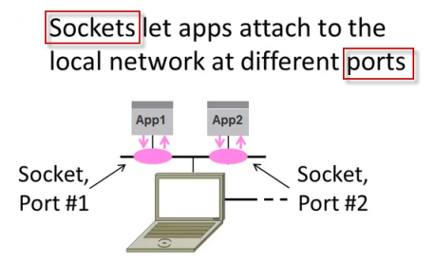

The basic mechanisms of client-server setup are:
- A client app sends a request to a server app.
- The server app returns a reply.
- Some of the basic data communications between client and server are:
  - File transfer - sends name and gets a file.
  - Web page - sends URL and gets a page.
  - Echo - sends a message and gets it back.

Server Socket
- create a socket - Get the file descriptor!
- bind to an address -What port am I on?
- listen on a port, and wait for a connection to be established.
- accept the connection from a client.
- send/recv - the same way we read and write for a file.
- shutdown to end read/write.
- close to releases data.

Client Socket
- create a socket.
- bind* - this is probably be unnecessary because you're the client,
- not the server.
- connect to a server.
- send/recv - repeat until we have or receive data
- shutdown to end read/write.
- close to releases data.

TCP vs UDP
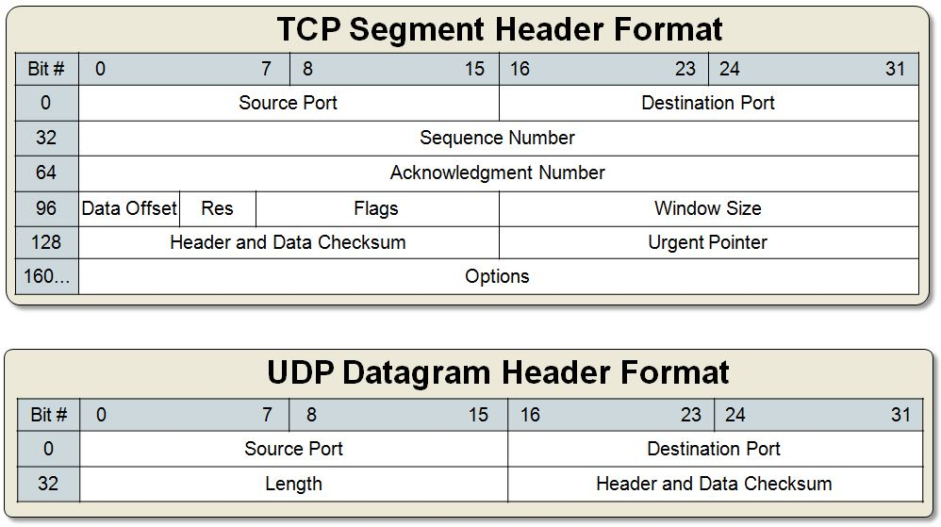

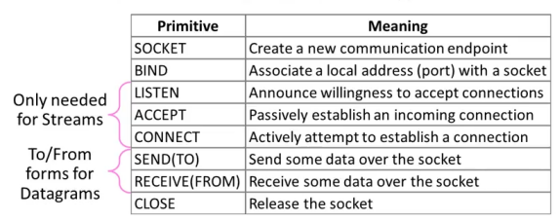

TCP (Streams) | UDP (Datagrams)
Connections | Connectionless sockets  We don't have to maintain an open connection as we do with stream sockets.  We just build a packet, put an IP header on it with destination information, and send it out.  No connection needed: datagram sockets also use IP for routing, but they don't use TCP  *note: can be connect ()'d if we really want.
SOCK_STREAM | SOCK_DGRAM
If we output two items into the socket in the order "A, B", they will arrive in the order "A, B" at the opposite end.  They will also be error-free. | If we send a datagram, it may arrive.  But it may arrive out of order.  If it arrives, however, the data within the packet will be error-free.
Why would we use an unreliable protocol?
Speed! We just ignore the dropped packets.
Arbitrary length content | Limited message size
Flow control matches sender to receiver | Can send regardless of receiver state
Congestion control matches sender to network | Can send regardless of network state
http, telnet | tftp (trivial file transfer protocol), dhcpcd (a DHCP client), multiplayer games, streaming audio, video conferencing  *note: They use complementary protocol on top of UDP to get more reliability

TCP communication

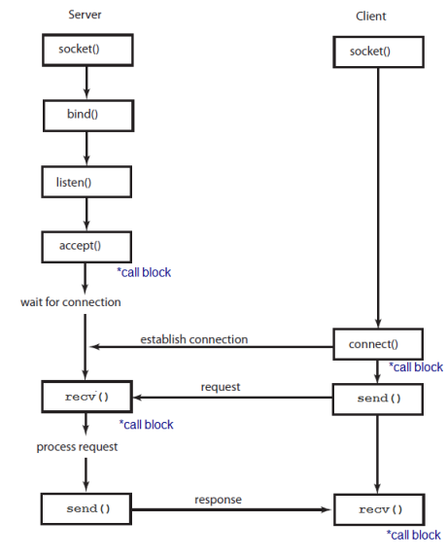

UDP communication - clients and servers don't establish a connection with each other
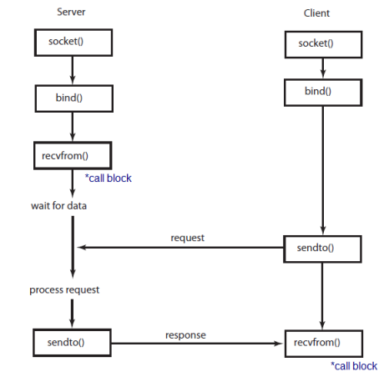

Steps for the experiment:
First create the socket, then call the socket fun (in order to connect to the other side of the socket we need to call the connect function), but before calling connect function we need to specifies an address connect to, then specify the actual server address, check for error with the connection, final steps is to receive date from the server.

Analysis:
TCP is connection oriented, i.e., it creates a connection for the transmission to take place, and once the transfer is over that connection is terminated. UDP on the other hand is connectionless just like IP (Internet Protocol). Reliability: TCP sends an acknowledgement when it receives a packet.
TCP is connection oriented once a connection is established, data can be sent bidirectional. UDP is a simpler, connectionless Internet protocol. UDP is faster than TCP, and the simple reason is because its nonexistent acknowledge packet (ACK) that permits a continuous packet stream, instead of TCP that acknowledges a set of packets, calculated by using the TCP window size and round-trip time (RTT).
We have learned how we can implement the TCP and UDP protocols for sending text and other file via the protocols by implementing the procedures for both the sender and reciever. We have clearly understood how these protocols can be used to communicate both the server to the client and the same server-client pc(where data is transmitted to another device location).

Source Code:

#include <WinSock2.h>
#include<iostream>
#include<stdio.h>
#pragma comment (lib,"ws2_32")
using namespace std;

#define DATA_BUFFER 512

void main()
{

WSADATA wsaData;
SOCKET sClient;
int i=0;

int isndLen;

char sndbuf[DATA_BUFFER];

memset(sndbuf,0,DATA_BUFFER);

char *Serip="127.0.0.1";
int SeriPort=5050;

struct sockaddr_in serAddr;

serAddr.sin_family=AF_INET;
serAddr.sin_port=htons(SeriPort);
serAddr.sin_addr.s_addr=inet_addr(Serip);

FILE *fp;

if(WSAStartup(MAKEWORD(2,2),&wsaData)!=0)
{
cout<<"failed to load winsock"<<endl;
return;
}

sClient=socket(AF_INET,SOCK_STREAM,0);
if(sClient==INVALID_SOCKET)
{
cout<<"socket() failed :"<<WSAGetLastError()<<endl;
return;
}

// cout<<"set link";
if(connect(sClient,(struct sockaddr *)&serAddr,sizeof(serAddr))==INVALID_SOCKET)
{
cout<<"connect() failed: "<<WSAGetLastError()<<endl;
return;
}
else
{
fp = fopen("C:\\Users\\ASUS\\Desktop\\1.avi","rb");
while(1)
{
cout<<endl;
i++;
memset(sndbuf,0,DATA_BUFFER);

//cin>>sndbuf;

if(fread(sndbuf,512,1,fp))
isndLen=send(sClient,sndbuf,sizeof(sndbuf),0);
else {
send(sClient,sndbuf,sizeof(sndbuf),0); break;
}}
fclose(fp);
}

closesocket(sClient);

WSACleanup();
}
---------------------------------------------------------------------
#include <WinSock2.h>
#include<iostream>
#include<stdio.h>
#pragma comment (lib,"ws2_32")
using namespace std;

#define DATA_BUFFER 512

void main()
{

WSADATA wsaData;
SOCKET sClient;
int i=0;

int isndLen;

char sndbuf[DATA_BUFFER];

memset(sndbuf,0,DATA_BUFFER);

char *Serip="127.0.0.1";
int SeriPort=5050;

struct sockaddr_in serAddr;

serAddr.sin_family=AF_INET;
serAddr.sin_port=htons(SeriPort);
serAddr.sin_addr.s_addr=inet_addr(Serip);

FILE *fp;

if(WSAStartup(MAKEWORD(2,2),&wsaData)!=0)
{
cout<<"failed to load winsock"<<endl;
return;
}

sClient=socket(AF_INET,SOCK_STREAM,0);
if(sClient==INVALID_SOCKET)
{
cout<<"socket() failed :"<<WSAGetLastError()<<endl;
return;
}

// cout<<"set link";
if(connect(sClient,(struct sockaddr *)&serAddr,sizeof(serAddr))==INVALID_SOCKET)
{
cout<<"connect() failed: "<<WSAGetLastError()<<endl;
return;
}
else
{
fp = fopen("C:\\Users\\ASUS\\Desktop\\1.avi","rb");
while(1)
{
cout<<endl;
i++;
memset(sndbuf,0,DATA_BUFFER);

//cin>>sndbuf;

if(fread(sndbuf,512,1,fp))
isndLen=send(sClient,sndbuf,sizeof(sndbuf),0);
else {
send(sClient,sndbuf,sizeof(sndbuf),0); break;
}}
fclose(fp);
}

closesocket(sClient);

WSACleanup();
}

